Data for this exercise: <https://drive.google.com/file/d/1_Zgi73vysPOzmVxziEiA5Fu7n_QPRZ1H/view?usp=sharing>

1. **Question:**

From the given data file, find the minimum math score, maximum reading score, and average writing score

**Answer:**

In the Min_Math column type =min(<select the math score array>)

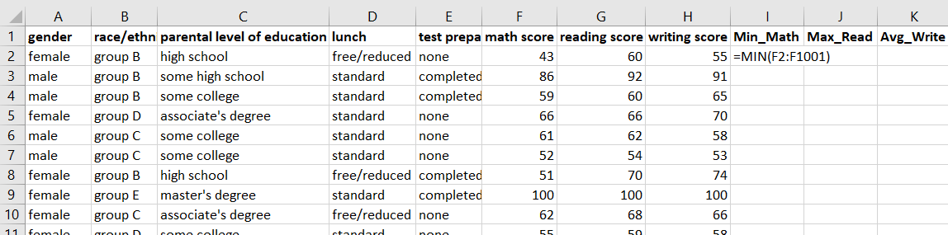

<press enter>

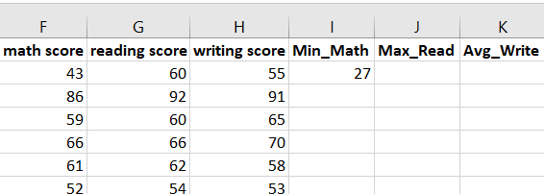

In the Max_Read column type =max(<select the reading score array>)

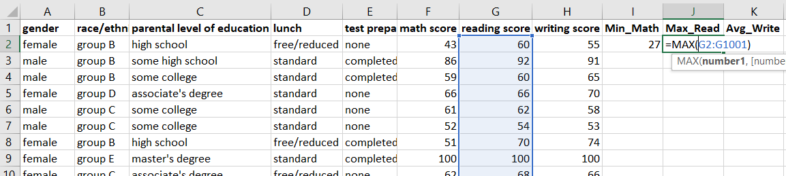

<press enter>

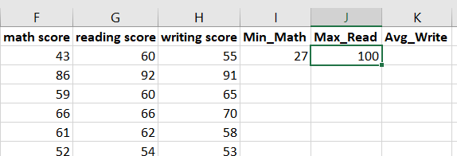

In the Avg_Write column type =average(<select the writing score array>)

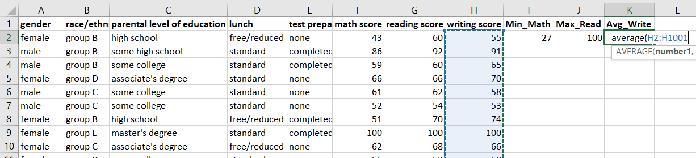

<press enter>

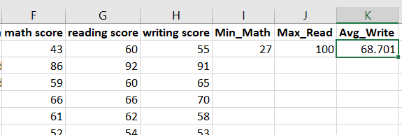

1. **Question:**

Find the average score for each student by using all 3 math, reading, and writing scores.

**Answer:**

To find average scores of each student: type =average(<math score 1st value>:<writing score 1st value>)

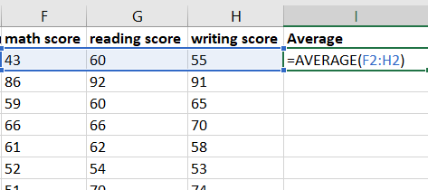

<press enter and drag till last record>

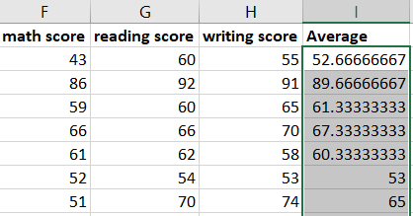

1. **Question:**

Find the Normalized math score using min-max normalizer.

**Hint:** use minmax normalization

**Formula:** (Xi - min(X)) / (max(X) – min(X))

**Answer:**

To get normalized math score: in a new column type =(<math score first value>-min(<math score array>))/(max(<math score array>-min(<math score array>))

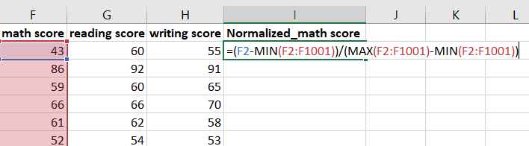

<press enter> and drag till last record

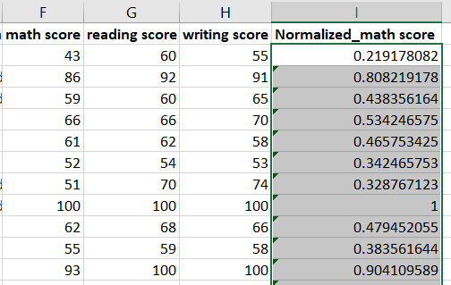

Normalized score will be between 0 and 1